**School of Computer Science**

**UNIVERSITY OF PETROLEUM AND ENERGY STUDIES**

**DEHRADUN, UTTARAKHAND**



**System Provisioning and Configuration Management**

**Lab File (2021-2025)**

# **6th Semester**

|  |  |
| --- | --- |
| *Submitted To:*  ***Dr. Hitesh Kumar Sharma*** | *Submitted By:*  *Abhay Chaudhary*  *(500090987)*  *B Tech CSE*  *DevOps[6th Semester]*  *R2142210016*  *Batch - 1* |

Lab Exercise 6– Terraform Multiple tfvars Files

**Aim:** Terraform Variables with Command Line Arguments

Step 1: Create a instance.tf file:

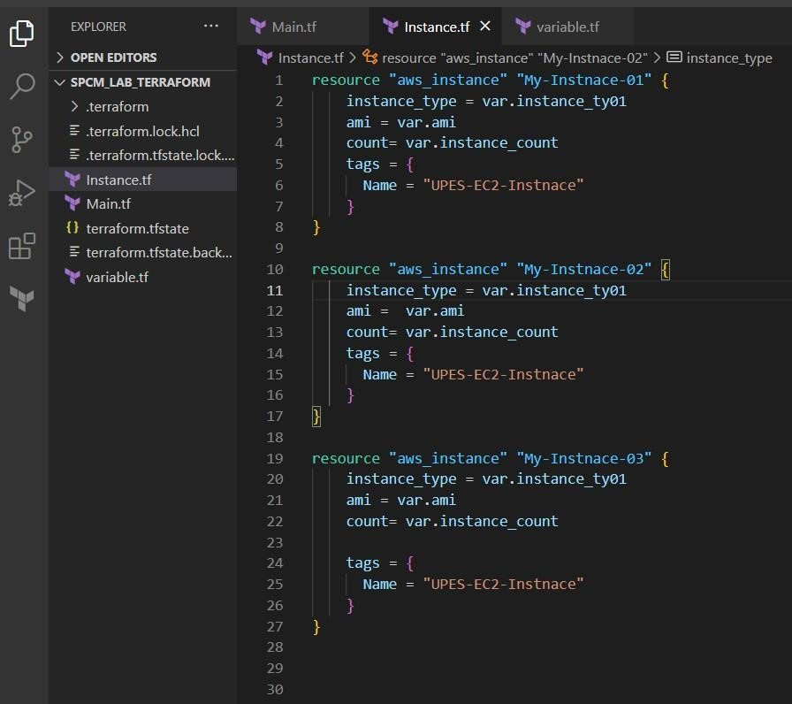

Step 2: Create a variable.tf file

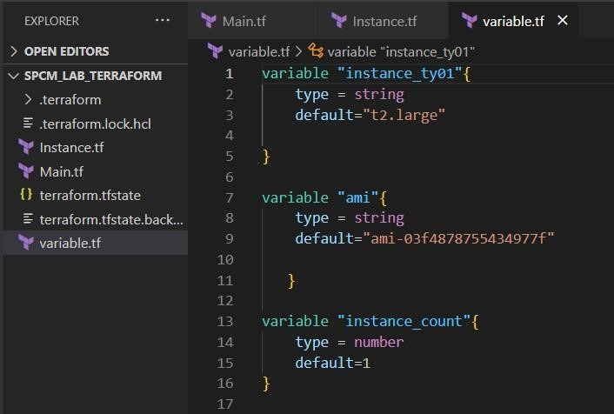

Step 3: Perform Terraform Validate And Apply

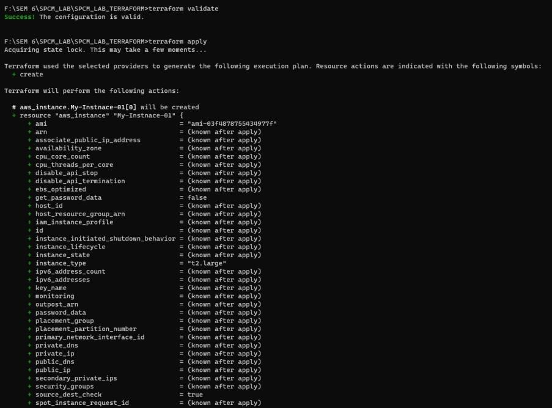

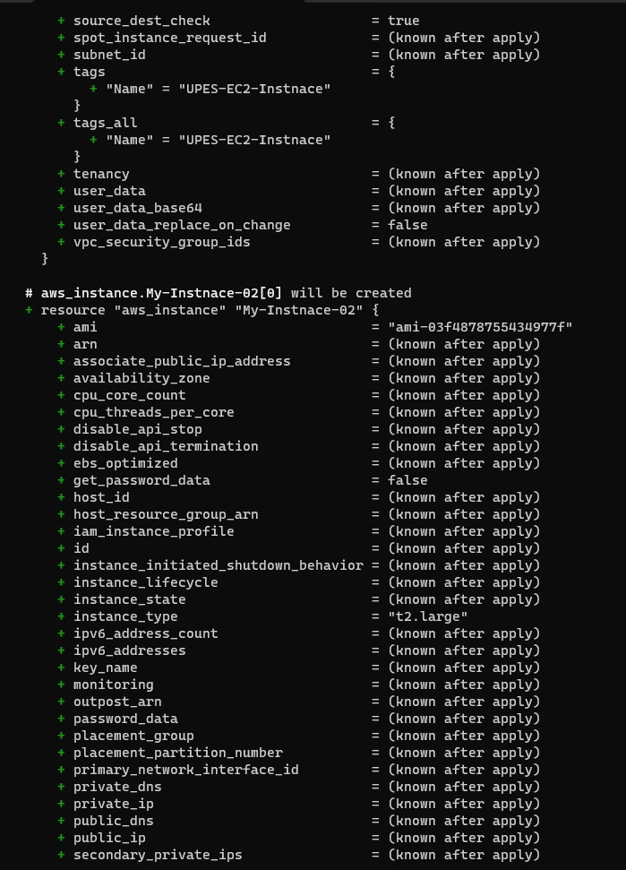

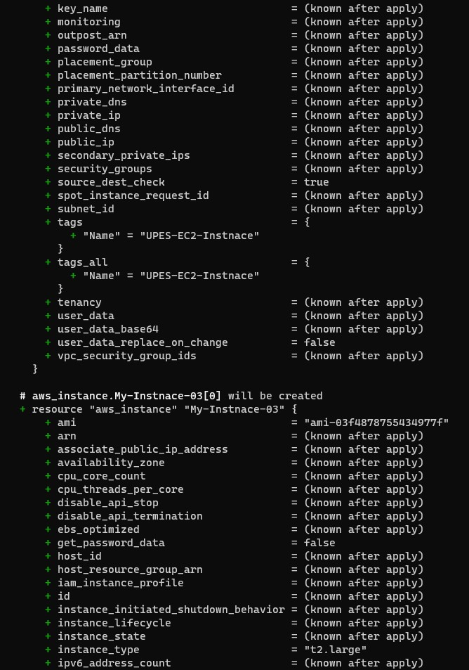

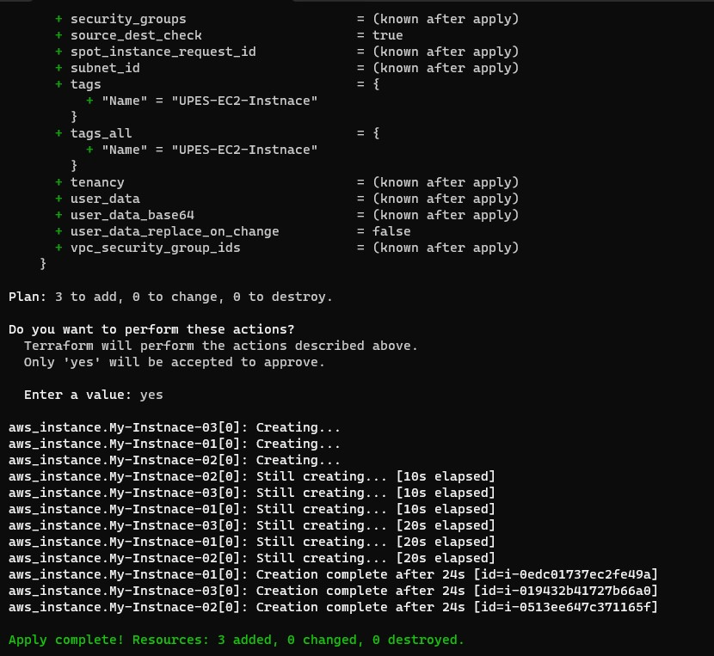

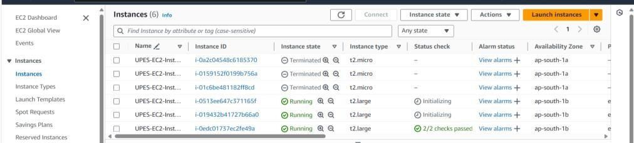

Step 4: Perform Terraform Destroy:

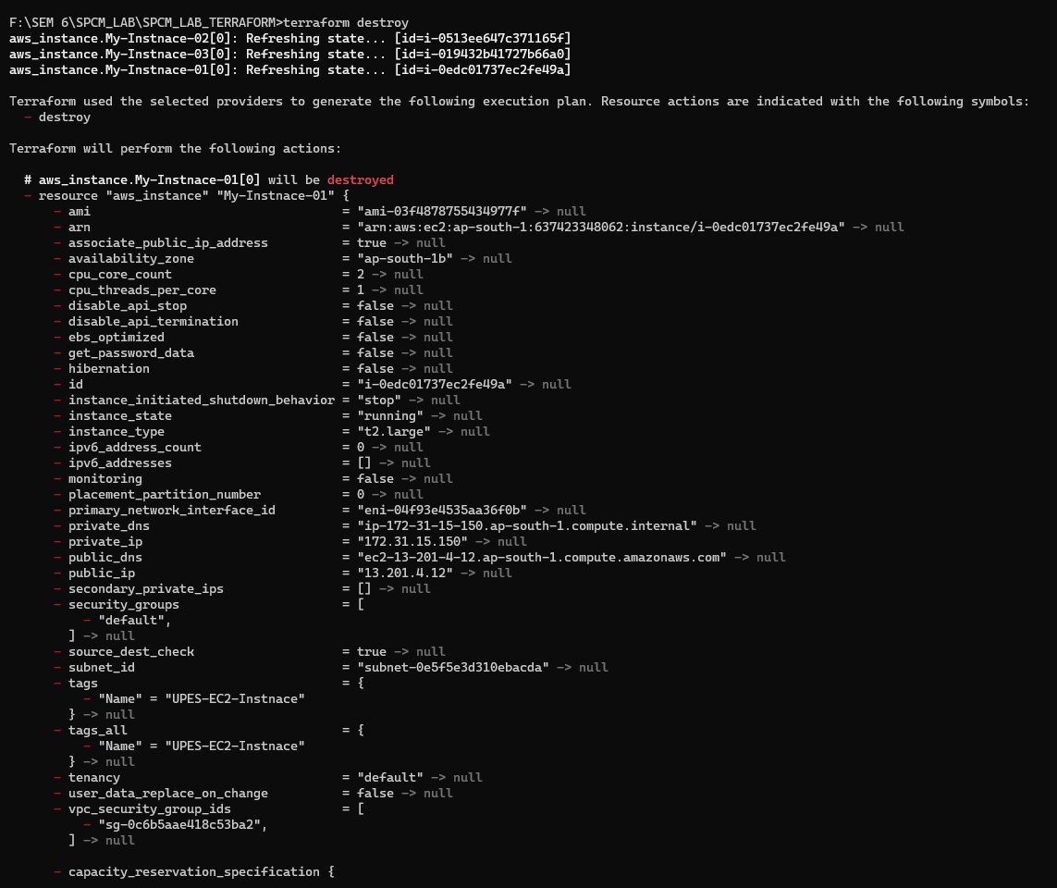

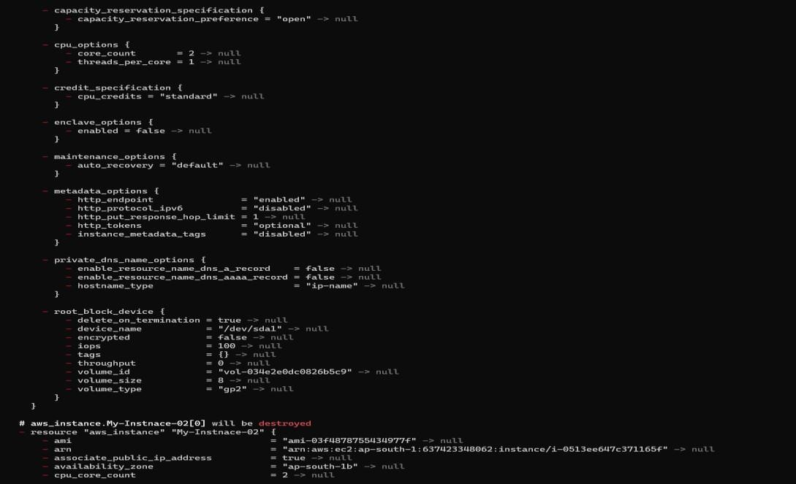

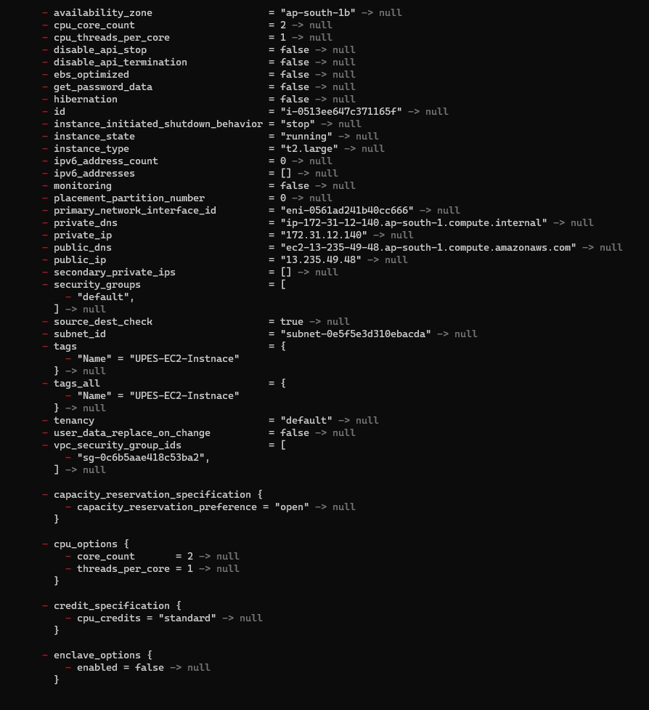

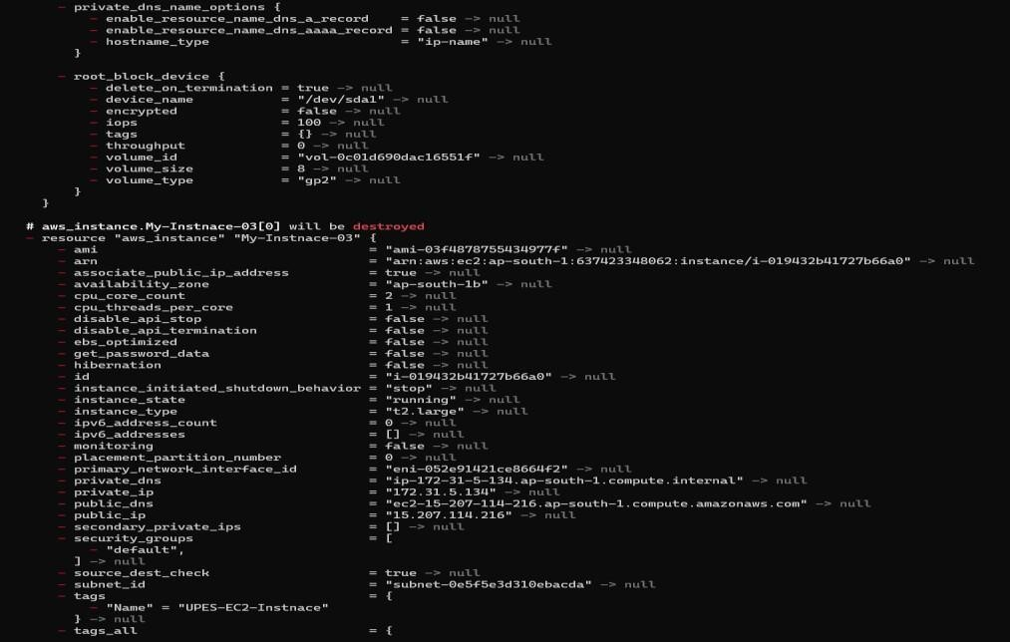

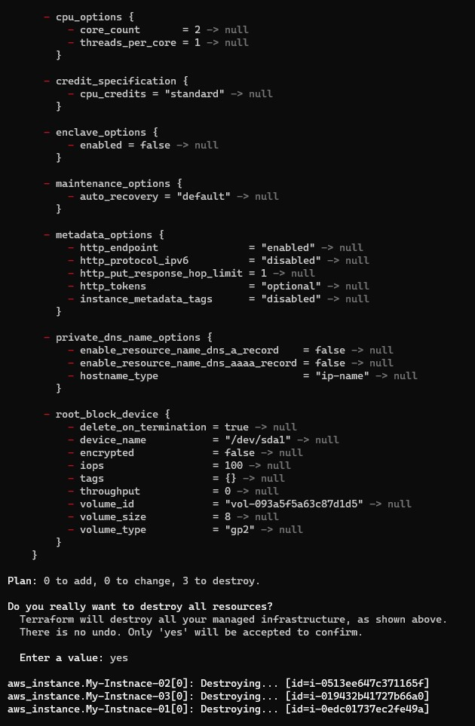

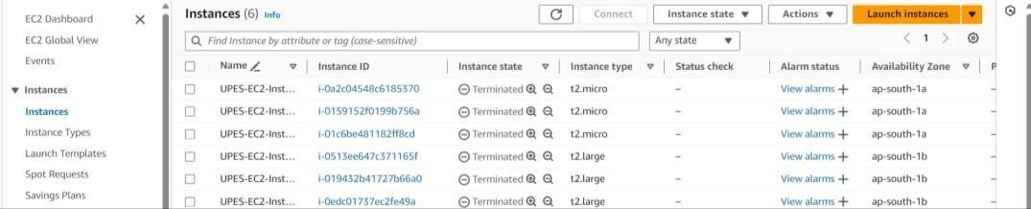

Lab Exercise 7– Creating Multiple IAM Users in Terraform

**Aim:** Terraform Multiple tfvars Files Objective:

Step 1: Create a instance.tf file

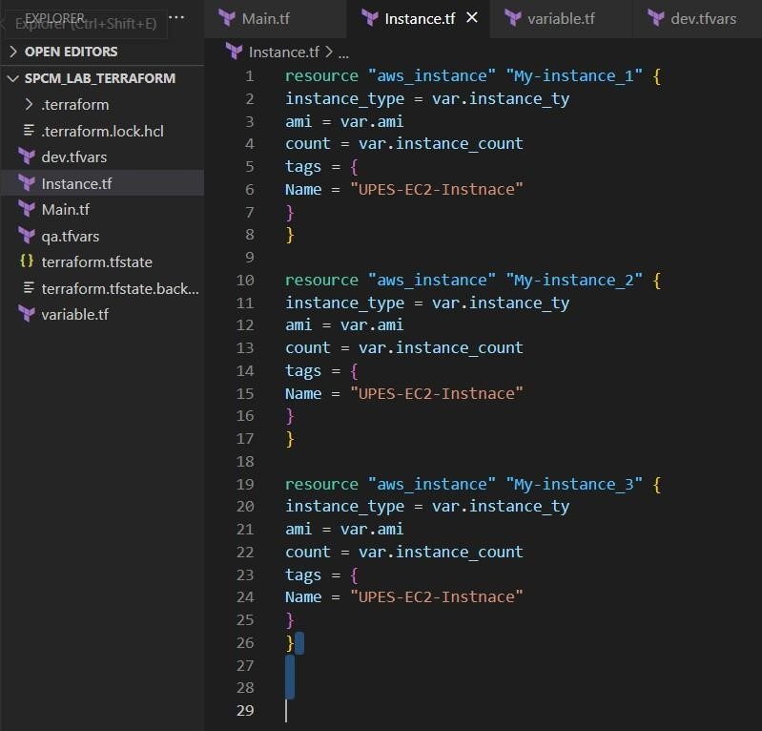

Step 2: Create a variable.tf file

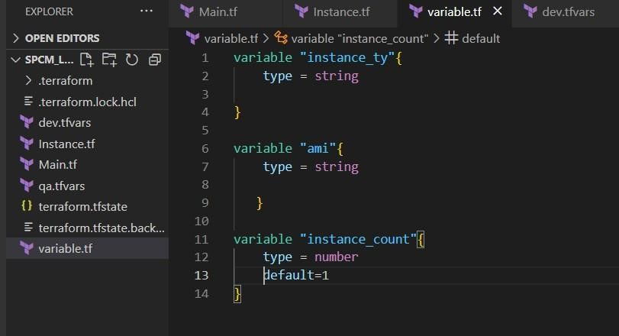

Step 3: Create Multiple tfvars Files: dev.tfvars

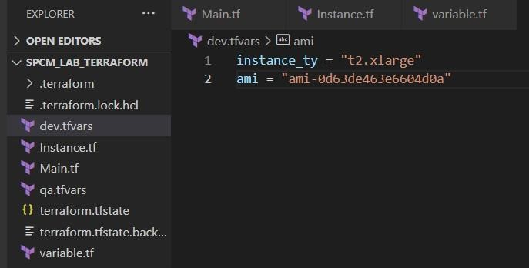 qa.tfvars

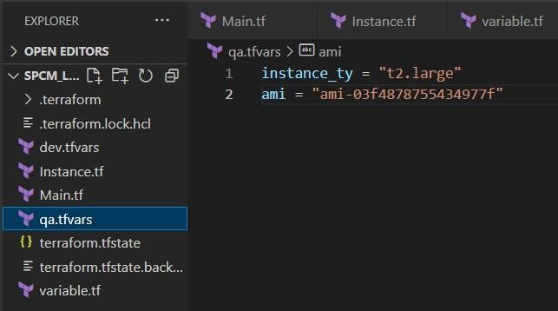

Step 4: Now initializes

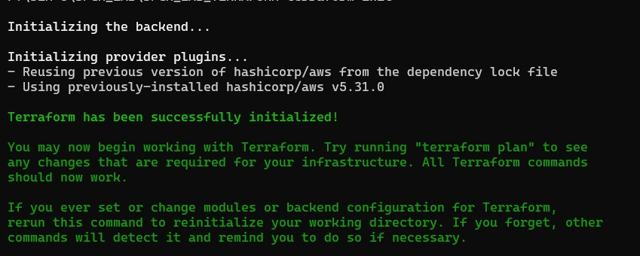

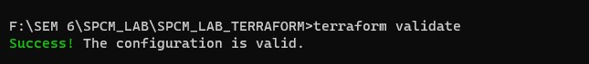

Step 5: Apply for Dev Environment

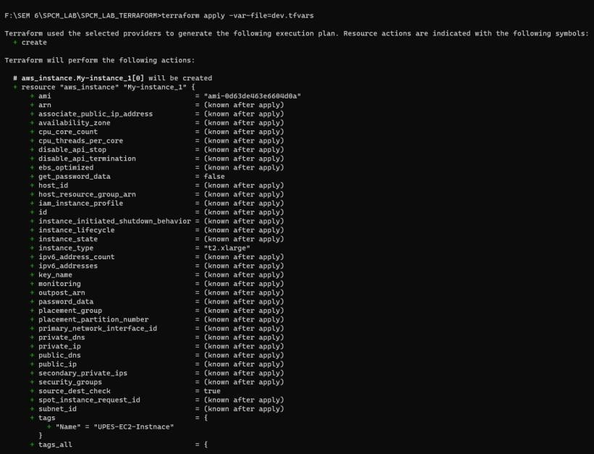

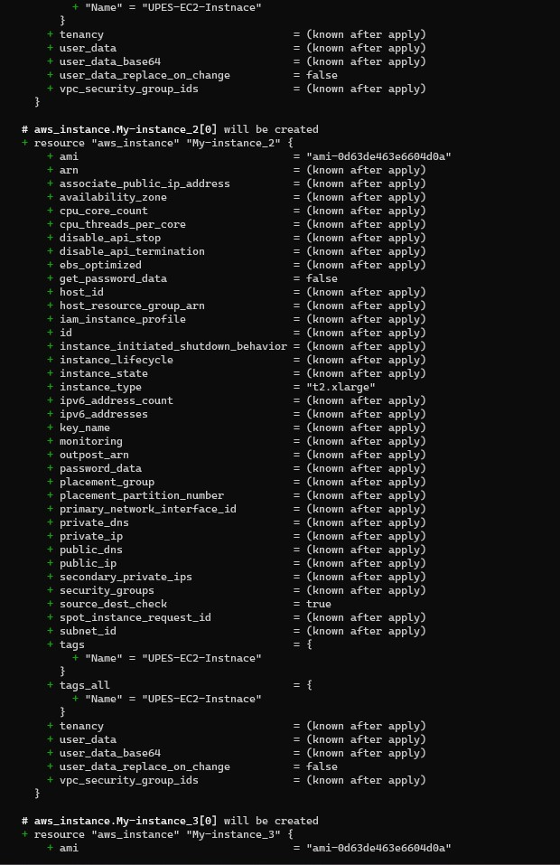

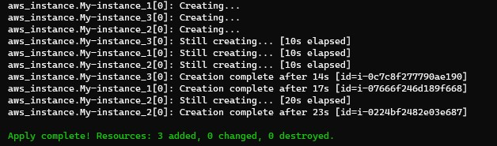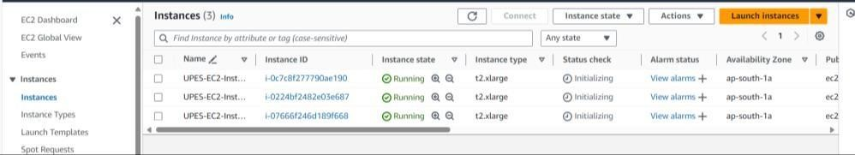

Step 6: Destroy Dev Environment

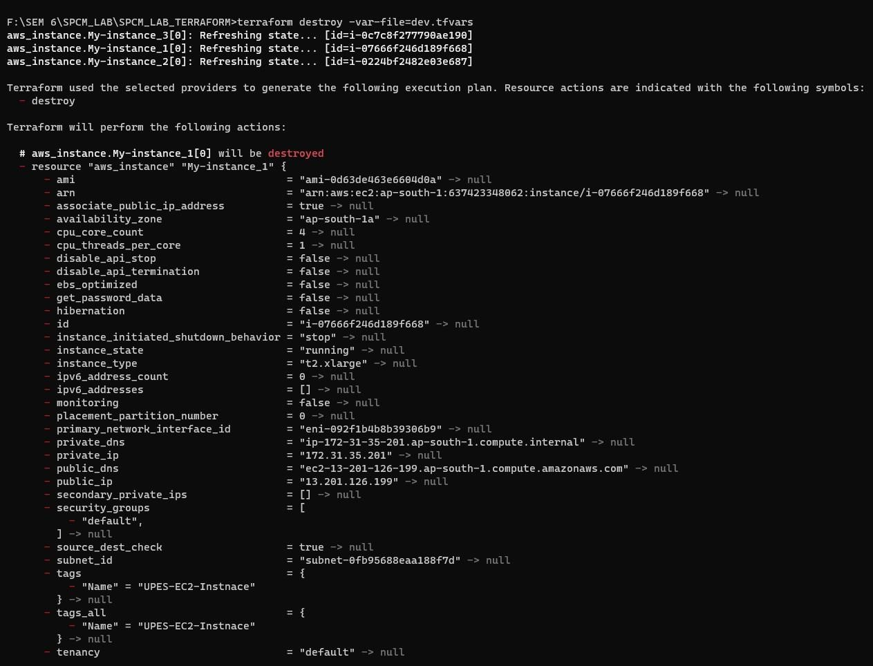

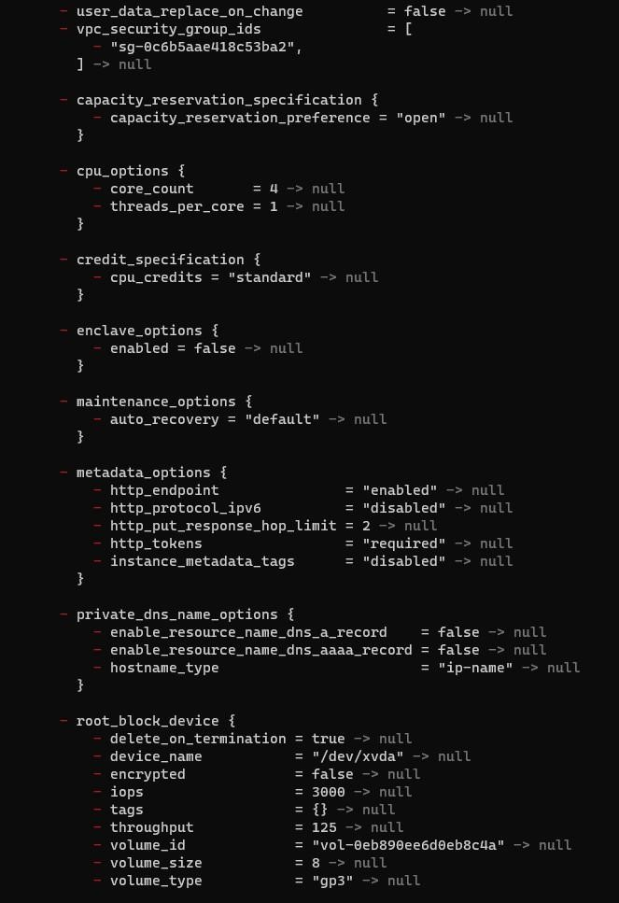

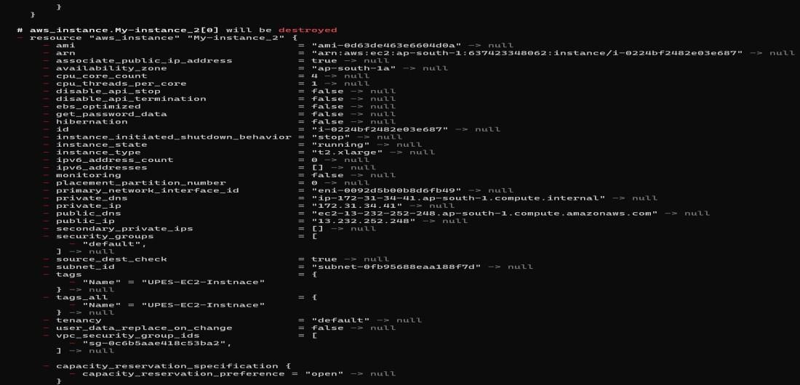

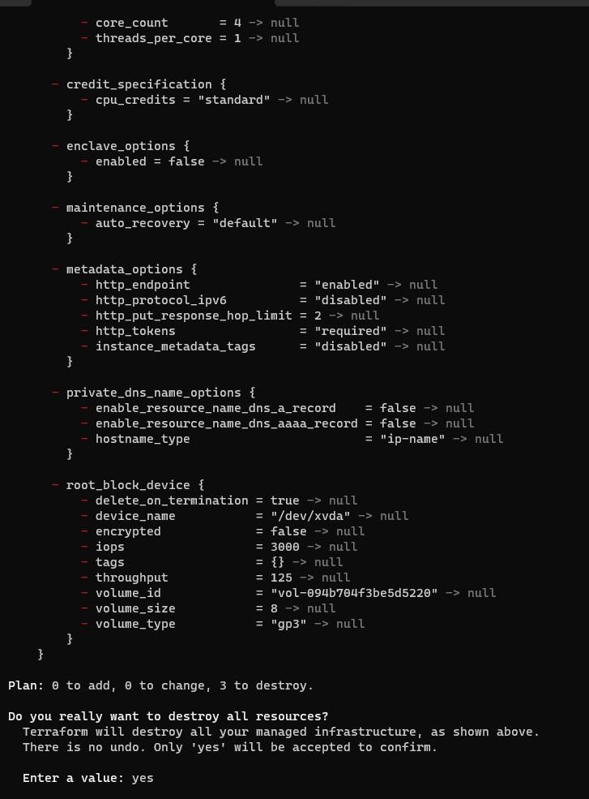

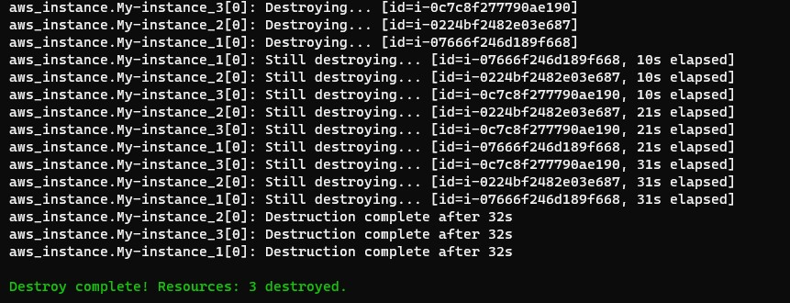

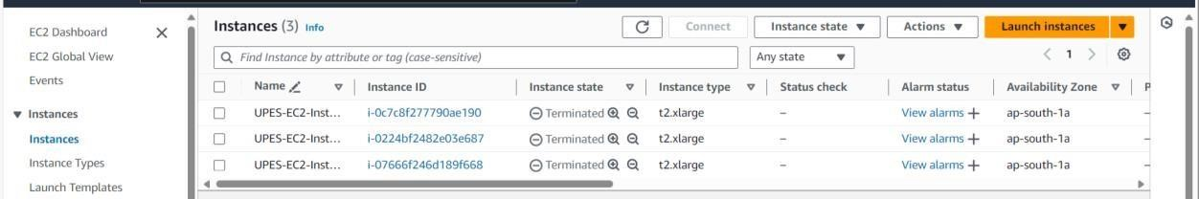

Step 7: Apply for Qa Environment

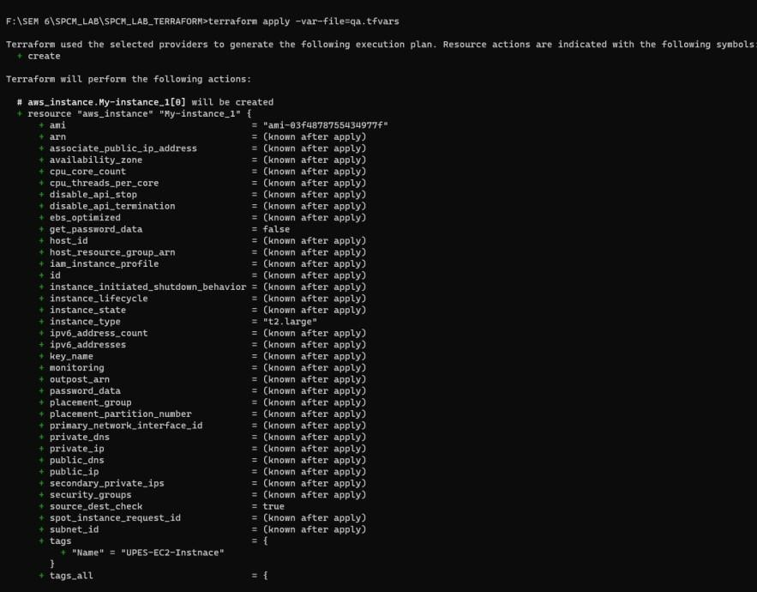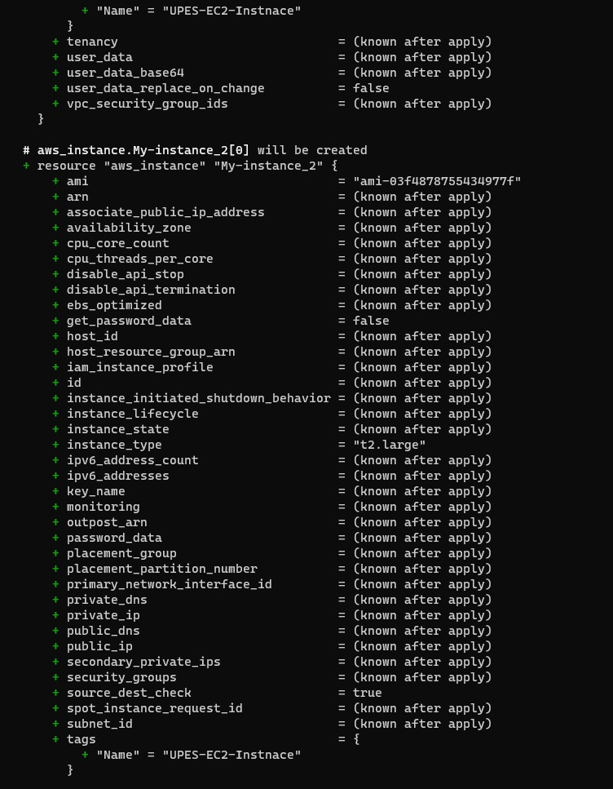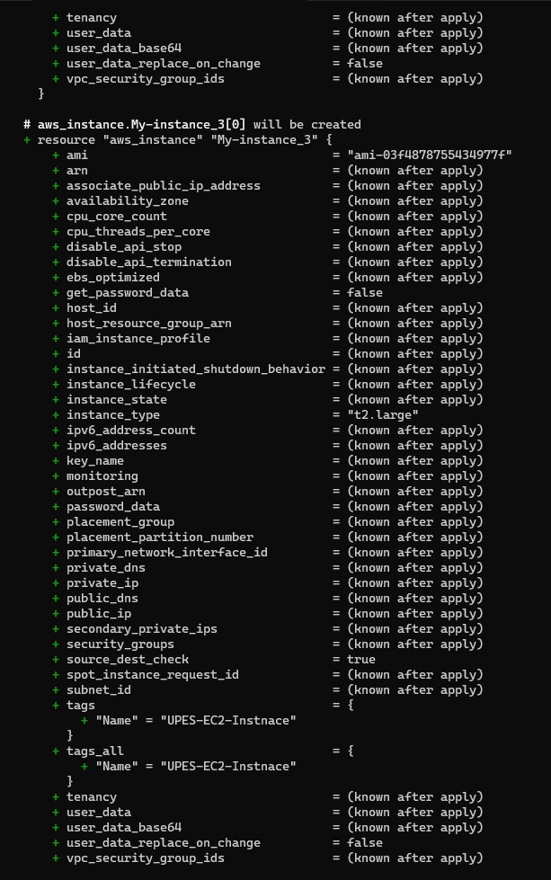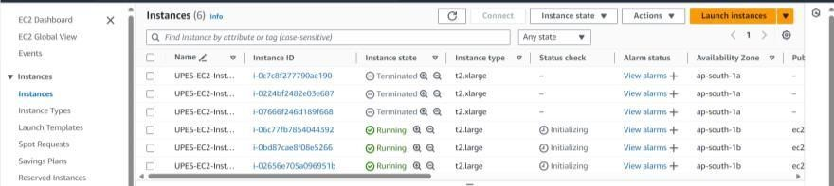

Step 8: Destroy for Qa Environment

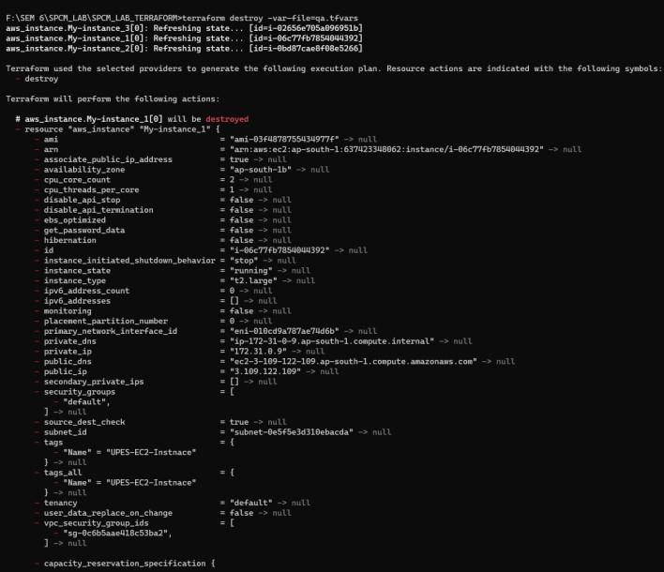

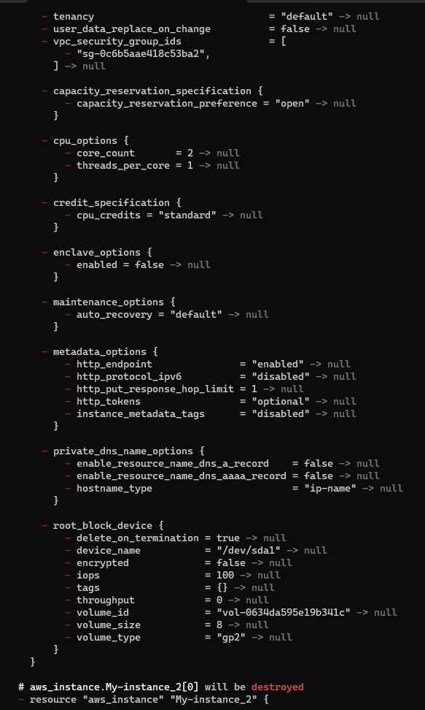

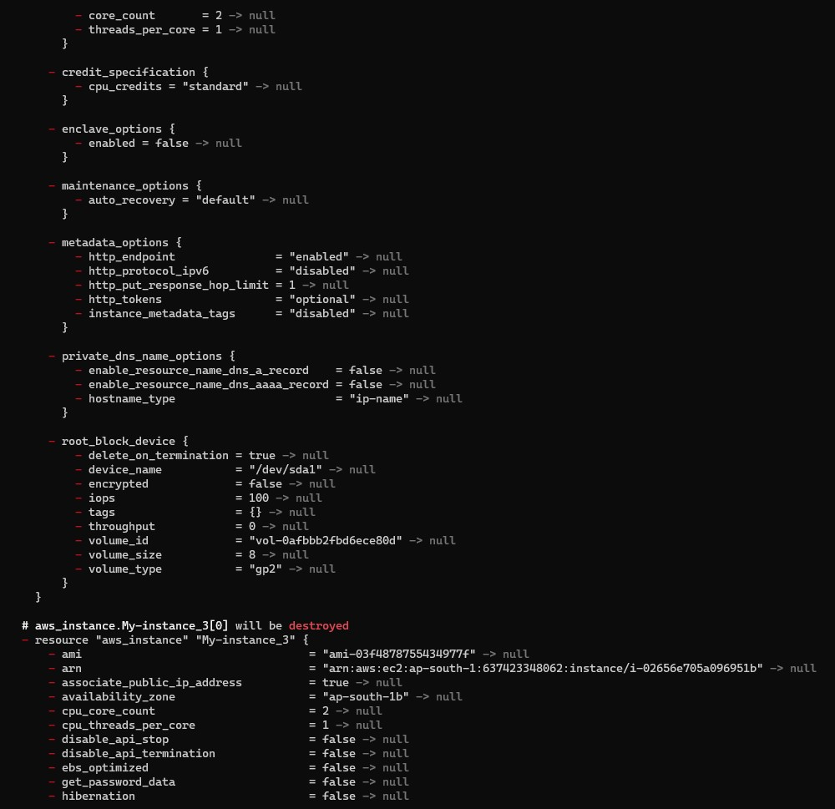

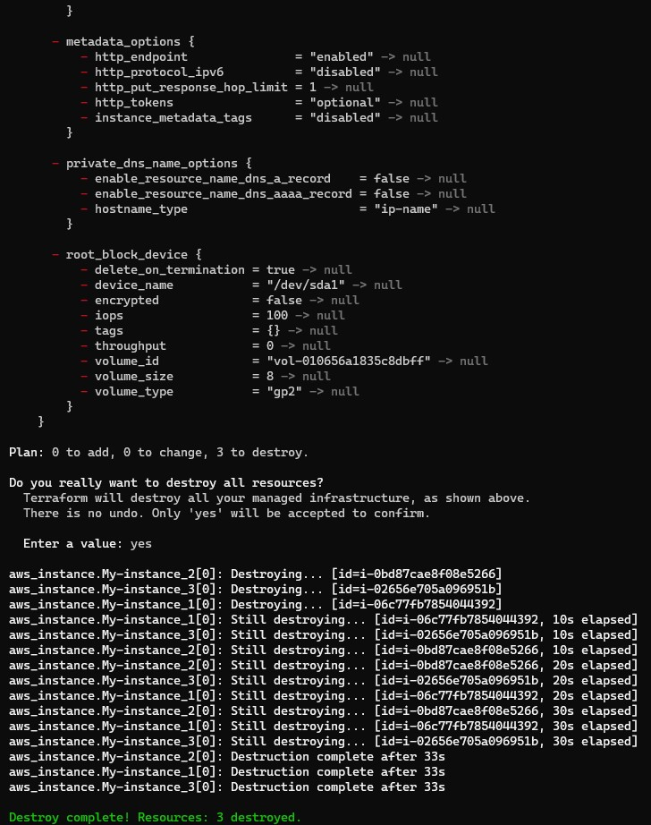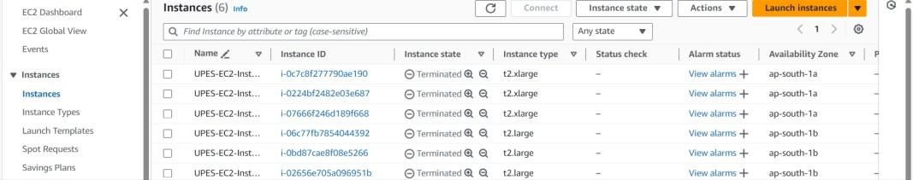

Lab Exercise 8– Creating a VPC in Terraform

**Aim:** Creating Multiple IAM Users in Terraform

Step 1: Create a main.tf file.

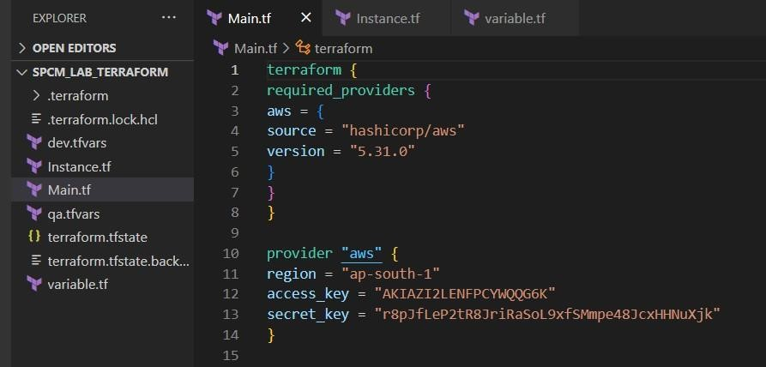

Step 2: Create a instance.tf file

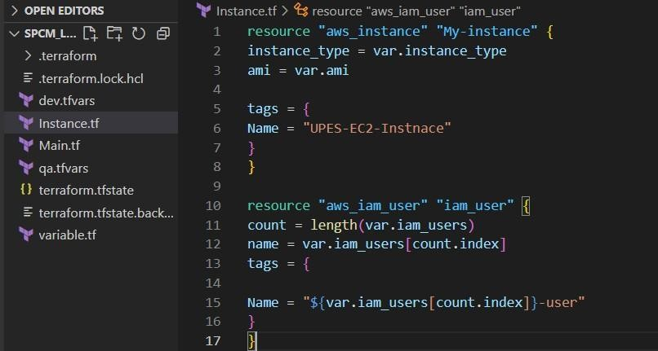

Step 3: Create a variable.tf file

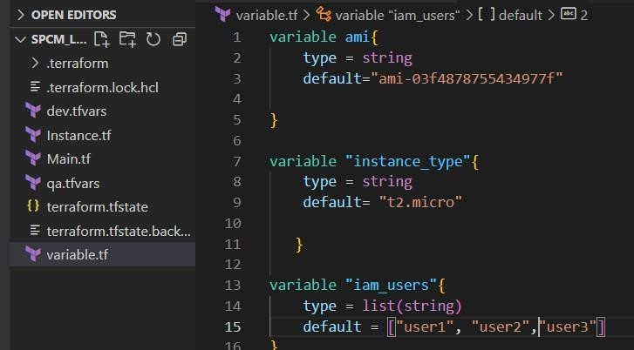

Step 4: Now initializes

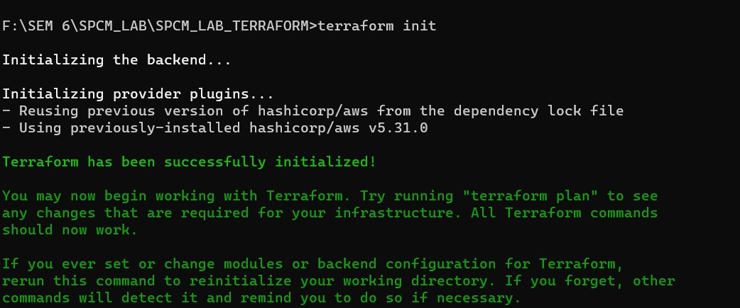

Step 5: Now perform validate

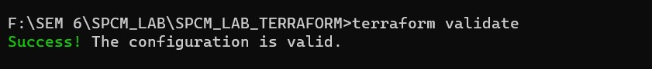

Step 6: Now perform the terraform apply

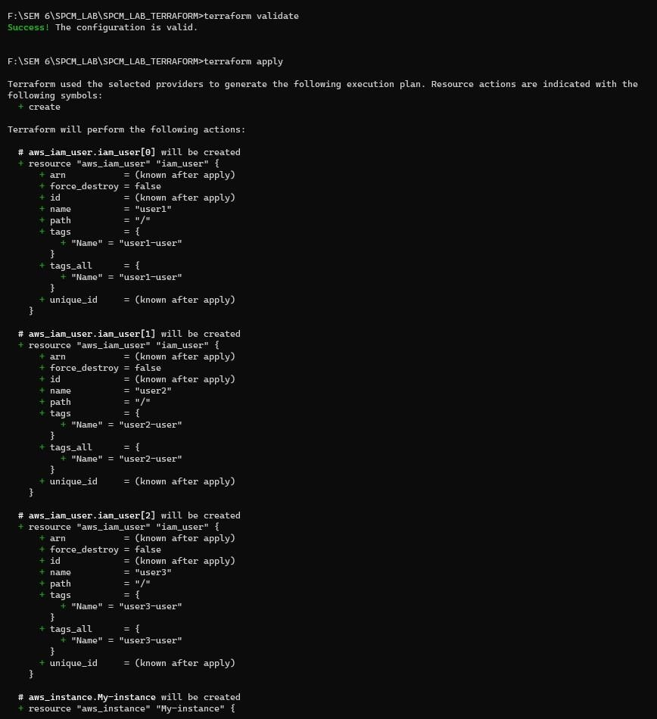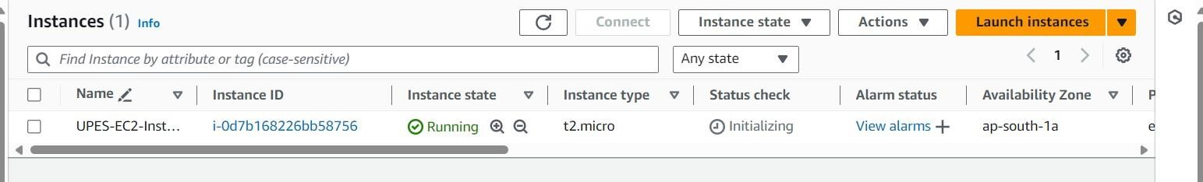

Step 7: Now perform Terraform destroy

